Profile Sheet Manufacturing Business Project

This project entails a comprehensive business plan for establishing a profile sheet manufacturing business from scratch. Profile sheets are vital components used in roofing for residential and commercial properties. The project encompasses thorough market research, strategic planning, operational logistics, and financial projections to ensure the successful launch and sustainability of the business.

**Contents:**

1. Executive Summary
2. Business Objectives and Related Strategy.
3. Principal Activities, Products and History.
4. The Market, Customer and Competition.
5. Research and Development.
6. The Management.
7. The Basis of Operation.
8. Major resource requirements.
9. Financial information.
10. Principal Risks.
11. The Long-Term plans for Business.
12. Detailed Information.
13. References.

# The Executive Summary

Profile sheets are the metals that are used as roofs, external walls and sometimes as floors. When it comes to creating either residential or commercial properties, roofing is an essential component. Every structure requires a stable and strong roof that can protect its occupants from the elements.

In the last decade, the Indian roofing business has undergone a fundamental transformation. There are two main reasons for the changes in the roofing sheet sector. One, in relation to the Indian market, there has been an increase in industrial uses. Second, consumers are dissatisfied with the traditional solutions provided and want more value from their roofing sheet purchases. As a result, there is a greater demand for various types of sheets to protect the roofs and walls of establishments.

Basically, they are of two types

1. Galvanized Corrugated Sheet (Traditional)

2. Galvanized Colour Coated Sheet

## Galvanized Corrugated Sheet: (GC Sheets)

Galvanized Corrugated Sheets are widely used throughout the country. Each purlin/batten that supports these sheets must be firmly grounded. Corrugated Galvanized Iron or Steel Sheets are a lightweight roofing material made up of thin sheets with corrugations to reinforce them. Corrugations, such as waves, greatly boost the lightweight material's strength and stiffness. Without these waves, the metal sheets are extremely weak and malleable. For shaping, mild steel is used, which is galvanized to strengthen the metal sheets' durability and, as a result, their capacity to endure the elements. This is a traditional method.

## Galvanized Color Coated Sheet: (CC Sheets)

When it comes to creating either residential or commercial properties, roofing is an essential component. Every structure requires a stable and strong roof that can protect its occupants from the elements. Roofing materials have become more diverse as a result of recent technological advancements. Color coated roofing sheets, for example, have recently acquired appeal in the building industry. This is due to its durability and flexibility, which makes installation easier.

Color coated roofing sheets are available in different shapes and sizes according to the application and can be used at different places such as offices, car parking, warehouses, restaurants, garages, godowns, manufacturing industries etc. They offer a wide range of benefits, some of which are mentioned below.

• Weather Resistant • Flexibility • Lightweight • Corrosion Resistant • Thermal Insulation • Durable • Environment Friendly • Attractive

Our objective is to establish a Color Coated Sheets Profile Sheet Industry in a location that is somewhat remote from major cities, and to service all rural and urban areas as needed. Our decision to locate industry outside of a large city is based on the fact that a major metropolis can only cover a radius of 100- 150 kilometres. As a result, if we establish industry far away from it, we will be able to cover the greatest number of rural areas.

We in the industry will mould the iron ore to our needs and size requirements after obtaining it from the leading organizations. In comparison to major cities, we will have a transportation advantage if we establish industry in rural areas. We can give Color Coated Sheets of the same high quality as those found in cities at a reduced rate.

If we are dealing with a small-scale industry, we can deal directly with clients; however, if we are dealing with a large-scale industry, we can hire distributors, dealers, and sub-dealers to boost our sales. Dealing directly with retail outlets is a fantastic idea because they are the only link between the company and the clients.

The main idea behind this business strategy is that, unlike plastic or fiber materials, these roofing sheets can be totally recycled in the future. They can always be melted down and manufactured into different roofing materials, making them completely environmentally friendly.

As this business consists of machinery and inventory place. We need build a production plant in an area which is approximately 10000 square feet. The facility will be equipped with space to install machines, to stock raw materials and finished products, and also includes office space.

The machines like Forming machine, cutting machine and Bending machines are required for the production line. Each machine can cost up to 25 lakhs Indian Rupees (25000 pounds). And the raw materials required are Gentle steel rolls, Plain iron sheets, Printing ink, wooden stands, lead and sulphuric acid. Metal sheets are purchased from established producers like JSW steel.

The manufacturing process of profile sheets starts with manually engaging the metal sheets into the forming machine, where the sheet is moulded into our required shape and size. Then the sheet is cut by the cutting machine. Then the moulded sheet is manually introduced into the Bending machine, where the machines make the sheet to bent shape at one end. And the trademark of the company is printed using printing machine.

We generally need eight labours for industry management in manufacturing, one to supervise the whole team and explain their jobs and remaining people are required for loading and unloading the materials and to transfer the materials from one production process to other. We also need a separate power transformer for generation of power.

The cost for establishing the factory costs us around 1 crore 50 lakhs Indian rupees (150 thousand pounds). The salary of employees and other maintenance costs would incur 3 lakhs (3000 pounds). As we order raw materials according to our usage, it would cost us around 50 lakhs (50000 pounds) per year.

As we are establishing our own retail outlets and eliminating the middlemen. We can sell the same high-quality product, as others, but at comparably low cost. And also, we are establishing our factory at outskirts of urban areas, so no transportation fee is incurred. We need to have a good branding advertisement which should attract all people. and only if our sale is over 20000 sheets per year (1800 sheets/month), by selling one sheet for 250 INR (2.5 pounds) on an average we may make a minimum profit of 45 lakhs (45000 pounds). At this rate, we can recoup our investments in 5 to 6 years.

# The Business Objectives and Related Strategy

## Business Objective:

Our main objective of the business is to produce long lasting, environment friendly and more reliable roofing sheets. As these sheets are made of stainless steel and fibre, we can easily melt them done reuse them for other purposes. In addition to following the quality standards and producing highly reliable products, we are providing them to the consumers in rural and urban areas at a much affordable price, compared to our competitors.

## Strategy:

Our target is to sell 1700 to 1800 sheets per month and over 20000 sheets per year. We can attract the customers with good advertisements and by our affordable prices for high quality profile sheets. we can achieve this target.

Our main plan is to manufacture goods far away from metropolitan city so that we can cover maximum rural areas and our investment will be less because the land value in rural areas is less compared to the land value in metropolitan cities, which are very high. Not only industry we need to have retail outlets too to increase our sales in the market which helps us to reach our monthly and yearly targets.

We can advertise our product in television and Movie theatres by signing any high-profile celebrity. Because in India, the celebrity endorsed products are very high in demand and sell themselves. And if we meet our yearly sales targets regularly, we can offer bonus and tour packages to our employees to boost their morale and encourage them to give their best to increase the sales. And in India there is a tax exemption on the money spent on the advertisements and promotions of products.

We have to be more familiar to the existing market price and then should decide on our products price. The current dealers in rural and urban areas, as they are importing finished profile sheets from factories in Metropolitan cities, are incurring transportation charges and charges from the supplier factories. So, they are selling 1 feet of profile sheet for 300 rupees (3 pounds). we as an independent factory in rural and urban area, will import the plain steel sheets from established suppliers. It will cost us around 160 rupees (1.6 pounds) per 1 feet sheet. As we don’t have any middlemen or dealers between us and customers, and we don’t have to pay any transportation fee. We can sell 1 feet of finished profile sheet at a price of 250 rupees (2.5 pounds). This affordable price will surely attract the customers.

# Principal activities, Products and History

## History:

As the company is relatively new and it is still in the form of an idea there is no history related to it. The companies in the same sector before produced mainly corrugated roof sheets in different arrangements like folded sheets, upset box sheets, covered fix and so on. And there was a long production process for these products. The production process consisted of cleaning the rust and other ingredients from plain iron sheets and then air drying them using dry, hot air. The dried sheets are then passed to molten lead to attain required thickness. Then the iron sheets are dried by forced air and fed to the feeding table by hoist or crane. Then they are conveyed to corrugating machine. After corrugation, the product is passed to correcting machine where the deformation in corrected. The product is then cut to the standard size and trademark of the company is printed.

## New Product:

At present, the way we are going to adopt to produce the roofing sheets is very simple and has less lead time of production. due to advancements in the production processes, the process of production is very simplified and the quality of the end product is also increased. And also, the roofing sheets we are going to produce will available in many different colours to attract the customers. This new type of sheets also offers a wide range of benefits such as Weather Resistance, Flexibility, Lightweight, Corrosion Resistance, Thermal Insulation, Durable, Environment Friendly and Attractive.

And also, the machinery we are going to use are the basic machinery required to produce a roofing sheet. If there is a new type of roofing sheet in future, these machines can also be used from them too. These machines can be easily understood and can be operated easily. There is no need of any expert to operate these machines.

# The Markets, Customers and Competition

I want to establish this factory at the outskirts of my home city Karimnagar, Telangana, India. The land value outside the city is less compared to the highest price of city land. Moreover, the areas around the city Karimnagar are a Granite Quarry Hub. There are more than 20 Granite quarry factories, which mine out the granite marble, cut them and distribute them to the consumers and also export them to all around the world. Many more granite factories are being established every year due to the abundance of marble granite in the area.

These factories will be our main customers, as their factories require roofing’s and walls which are made of profile sheets. Their factories consist of a factory outlet for the machinery to cut the marble and a separate outlet to store the mined granite and granite that had been cut. As result of this, these factories are in need of large quantities of roofing and wall materials. So, there is a booming market and derived demand for profile sheets in this area.

And also, Karimnagar had been recognised as a smart city by the government of India. Therefore, large number of developments and construction are being done in and around the city. Along with this, there is increased number of private housing construction. All these activities require roofing sheets for to store the construction materials during the construction, to cover the roofs for car parking and to establish a temporary shelters to the construction workers.

We should remember that, there are already well-established retail outlets of roofing sheets, they are our competitors in these areas. These retail outlets in turn import the profile sheets from the factories in the metropolitan city Hyderabad. So, their prices are staggering compared to our prices of selling the profile sheets. Therefore, we have a competitive edge over them with our affordable prices.

# Research and Development

Our first step to start this business idea is to get a land in a location outside of the city near to the area of granite factories. We need a finance of at least 50 lakhs INR (50,000 pounds) to buy the required land.

And also, we have to secure different permissions from the government before starting the business like:

* All units which consume 5 HP power consumption or above should take NOC or sanction from pollution control board.
* We should register in GST network of India as it deals with the Goods and Services.
* Factory licence in India under FA 1948 and factory permit from local authority.
* Manufacturing licence under product certification scheme of Bureau of India Standards (BIS).
* ISO 9001:2015 Certificate.

# The Management

In the factory, we would require 8 workers to work in the manufacturing process, and for loading and unloading the raw materials and finished goods. A supervisor will manage all the operations in the factory. He is responsible to teach the workers how to operate the machines and run the production process. And, we would need 2 sales managers for marketing and distribution of our product. These managers will solely be responsible to attract the customers to buy our products and they also need to oversee the distribution of the finished goods to the customers. To increase our sales, we can hire a strategy consultant or an intern for making our customers experience satisfactory with us.

The supervisor should be a qualified engineer, who can understand the machinery and the process of operations. Having an experience candidate for supervisor can be an added benefit. The workers who work in the production floor need to have a basic education and can be able to learn and understand the safety measures and the methods to operate the machinery. We compulsorily need experienced sales managers to work with us. The sales managers need to update the supervisors regarding the customer requirements and order size to keep up his production process. Also, the supervisor needs to specify a delivery date to the managers, so they can inform the customers the details of their delivery.

Supervisor is the most important person in this flow of operations. He needs to keep track of the inventory and give and an order forecast to the supplier.

# **The Basis of Operation**

Apart from the factory, we plan to establish two retail outlets of our own. One beside the factory for the customers from the granite quarry factories. And one in the city, which will be accessible to the local contractors and builders.

We will store a certain amount of inventory in both the stores. They are replenished according to the sales. If a customer requires large number of sheets. We can give them a lead time of 3 to 6 days depending on the size of the order. The raw materials (plain sheets) should be ordered beforehand on a monthly forecast.

Our main suppliers could be TATA steel Ltd or JSW steel. We can sign a contract on fixed cost for a specified period of time. If in some case our supplier is unable to meet our order requirements, we can get the sheets from our competitors at high price only to keep our customers satisfied with us, and avoid losing them to our competitors.

The manufacturing process of profile sheets starts with manually engaging the metal sheets into the forming machine, where the sheet is moulded into our required shape and size. Then the sheet is cut by the cutting machine. Then the moulded sheet is manually introduced into the Bending machine, where the machines make the sheet to bent shape at one end. And the trademark of the company is printed using printing machine.

To manage the accounting system of the business, we need to hire a chartered accountant. He will be responsible to manage our purchases and sales and keep the record of all our expenses and salaries to our employees. In future, if we expand our business to other places by establishing retail outlets there or by hiring dealers, chartered accountant will be very useful to track the flow of money.

# Major resource requirements

We need a total revenue of 1 crore INR (100,000 pounds) to start the business of profile sheet industry. The cost of the land will be 50 lakh INR (50,000 pounds). The construction of the facility will cost us around 30 lakh INR (30,000 pounds). To order the plain sheets from the supplier on a one-month forecast, we need to pay a certain advance of up to 3 lakh INR (3000 pounds). And also, as we are setting up 2 retail outlets of our own. One will be constructed be constructed near our factory and we will rent one store in the city to set up our second outlet.

And we also need a power generator to generate the power required to run the machines.

We will need the required amount for setting up the business at least 2 months before starting the business. If we reach our targeted sales regularly, we can recoup our investment amount in 4 to 5 years.

# Financial information

The fixed costs that are incurred in this business are 12000 pounds for the salary of employees and other miscellaneous costs of 2500 pounds. So, the fixed cost is 14500 pounds per year. And the cost per unit product is 2.5 pounds. The variable cost is 1.6 pounds per unit product for raw materials imported from the supplier.

Break even point = fixed cost / cost per unit – variable cost

= 14500 / 2.5 – 1.6

= 14500 /0 .9

= 16111

So, the break even point of our company is 16111 pounds.

The projected profit and loss statement of the company is

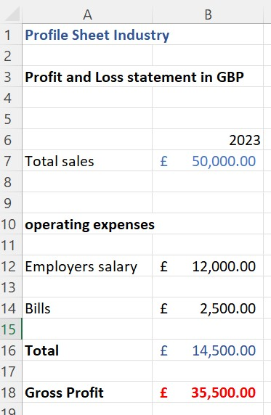

# **Principle risks**

We should follow the market price for our product always. Some time it may increase or decrease depending on the cost of raw materials and the price of steel. When the price is stable and we are able to achieve our target sales, we can get an operating profit of 35500 GBP per year. Suppose, if the price drops to 2 pounds per sheet and our sales are 20000, we can get a profit of 25500 GBP per annum. In the same way, we can see all the possible scenarios in the fluctuations of price of the sheet and our target sales and so the relative profit we can get in the below picture.

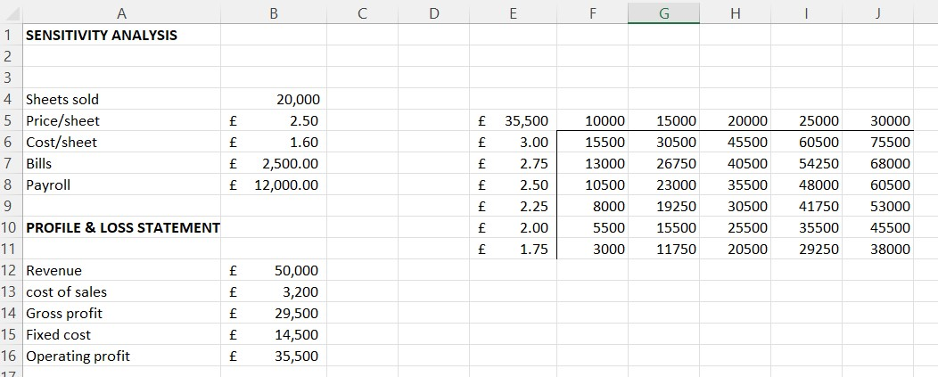

In the same way, the profit can increase or decrease depending on the cost of sales and due to changes in distribution price.

# **The long-term plans for business**

Based on the mentioned sales forecast, we can recoup our investment revenue in 4 to 5 years. In future, if we want to expand our business, we can establish more retail outlets of our own in surrounding urban and rural areas. If it is riskier to maintain an outlet in other areas, we can hire dealers and distributors in those areas and can export our sheets to them.

If we can find any investors, we can start our business on a large scale. In that case, we can increase our production capabilities to produce a greater number of sheets and establish more retail outlets in nearby urban and rural areas .as we are selling our products at a very affordable price, compared to our competitors, we can easily attract customers and so can increase our target sales per year.

At this rate, our investors can expect to earn profits after 4 to 5 years after starting the business. The time may seem long, but we never know what can happen once after we insert ourselves into the business. We may achieve the profits within 3 years also, if we can successfully establish deals and contracts with corporate construction companies.

# Detailed Information:

**Appendices:**

**Business Plan:**

Our is Business Plan is to establish a Profile Sheet (or) Roofing sheets Manufacturing industry in a place like rural and urban areas where the dominant industries from metropolitan cities are selling their products through dealers at a high price. We want to produce high quality color coated profile sheets which are an advanced version of roofing sheets and provide them to consumers in remote areas at a much affordable price.

**Financial assumptions:**

* An investment of 100,000 pounds is required.
* The investment is used to buy a suitable land, establish a factory and to buy the required machinery.
* Estimated pay back period is 5 years.

**Details of Management:**

* One supervisor is required to run and monitor the production process.
* 2 sales managers to promote sales and bring customers.
* 8 workers to work on production making line.

1. **References:**

* Narayan, Adi. MacAskill, Andrew. In India Slum Roofing is Cheap and Deadly. Source: Bloomsberg.com. Business Source Premier.
* Personick, Martin, E. (1990). Profiles in Safety and Health: Roofing and Sheet metal work. Vol 113, Issue 9. Monthly labour Review.
* Nicholson, Mark. (1999). High-Risk strategy begins to pay-off off for Indian high-tech pioneers: Ramco software group is becoming a world-class enterprise. London (UK). Financial Times.
* Research and Demand. (2011). Roofing Industry in India 2011 – Rising Aesthetic sense among the Consumers has increased Demand. Dublin. Business Wire.